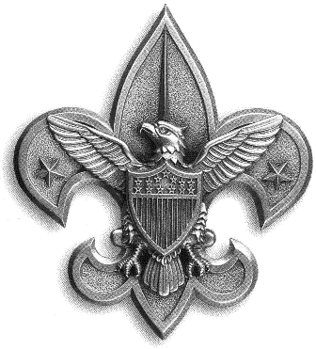
BSA Troop 54

PERSONAL FITNESS MERIT BADGE

The staff of the JCC is extremely excited about working with our troop on this Eagle required merit badge program. Each meeting will be a combination of discussion and working with equipment /exposure to new skills. Some of the physical components may be spinning, yoga, stability ball or weight training. The JCC staff and adult leaders from the troop will assist with the Flexibility Test and the Body Composition Test. It promises to be great fun, and a terrific way to get in shape!

Please visit www.meritbadge.com as soon as possible for a complete description of the merit badge requirements.

All scouts are invited to participate in these four sessions. Please note, however, that for any scout committed to obtaining this badge, there are certain preconditions:

- Before you try to meet any of the requirements, please be sure that your health care provider has given you a physical examination and that you have had a dental checkup within the past year. You must bring in verification (a report or note) from both your doctor and dentist at the first meeting.
- You are expected to come prepared with written responses that will be discussed at a given session to questions asked in steps 1-5 in the merit badge booklet. The merit badge counselors will review these responses. If a scout is unable to record his responses, he must speak with Mark Lefkowitz prior to April 21 to make alternate arrangements.
- You must wear sneakers and appropriate, comfortable apparel for exercise. Bring a water bottle to each session.
- The JCC staff’s time is valuable…sessions will not be made up!
- Meetings will start promptly at 6:00!

Here’s the schedule of sessions:

April 21: Session one: Discuss steps 1 and 2 and a physical component
May 5: Session two: Discuss steps 3 and 4 and a physical component
June 2: Session three: Discuss step 5 and a physical component
June 16: Session four: Flexibility Test, Body Composition Test, Discuss 12 week program

If you are interested in working on this merit badge, or have any questions, please contact Mark Lefkowitz at 781.784.5293 or Biomedvis@attbi.com. If you plan to work on this badge, AND to allow you enough time to prepare for the first session, I must be notified by APRIL 1 so that I can get a Personal Fitness Merit Badge booklet for you!

